# Why Python?

****Python is an easy-to-learn****, ****powerful programming language****. It has efficient high-level data structures and a simple but effective approach to object-oriented programming. Python’s elegant syntax and dynamic typing, together with its interpreted nature, make it an ideal language for scripting and rapid application development in many areas on most platforms. In addition to that, Python is one of the most popular languages used for Machine Learning development.

****It has a large number of libraries and frameworks****: The Python language comes with many libraries and frameworks that make coding easy. This also saves a significant amount of time.

****The most popular libraries**** are [**NumPy**](https://numpy.org/learn/), which is used for scientific calculations; **[SciPy](https://scipy.github.io/devdocs/getting_started.html" \l "getting-started-ref)** for more advanced computations; [**Pandas**](https://pandas.pydata.org/getting_started.html) for data analysis and manipulation, and [**Sklearn**](https://scikit-learn.org/stable/getting_started.html), for data analysis and Machine Learning algorithms. Don't worry, we'll cover all these libraries during the 4 month ML course.

These libraries work alongside powerful frameworks like [**TensorFlow**](https://www.tensorflow.org/tutorials), [**PyTorch**](https://pytorch.org/tutorials/), [**Keras**](https://keras.io/guides/), and many more and are essential when it comes to machine and deep learning projects.

Learning Python is fairly easy if you have any experience with programming and it's also simple to pick up as a first language.

However, before we dive into theory, let's first go over some ****tools setup you'll need for the Admission Course****: to start, the ****Jupyter Notebook**** environment will be used to teach a large portion of the course and is a staple in the machine learning community.

**Setting up your work environment**

To ****make it as simple as possible for you to learn****, where you don't have to install and configure software and runtimes on your local computer and deal with all the associated problems, here we are introducing you to ****Jupyter Notebook****, an environment where you will be able to ****run code directly from your browser****.

## ****What is a Jupyter Notebook?****

The ****Jupyter Notebook**** is an incredibly powerful ****tool for interactively developing and presenting ML projects****. A notebook integrates code and its output into a single document where additionally you can combine it with visualizations, texts, mathematical equations, and others. In other words: it’s a single document where you can run code, display the output, all being executed in your browser. This allows you to make your work more understandable and shareable to collaborate with others.

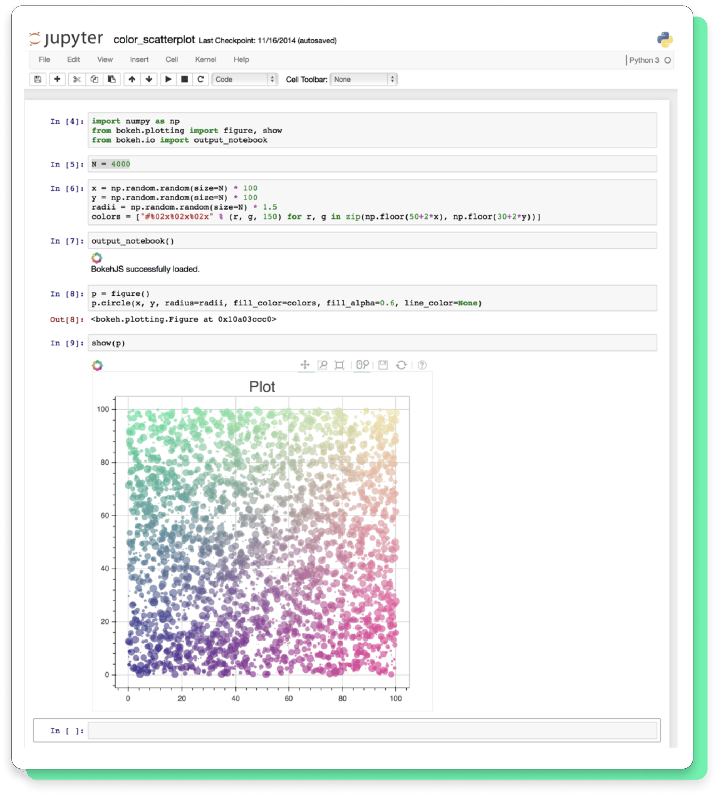

Using ****Notebooks**** is now a major part of the ML workflow at companies across the globe. If your goal is to work with data, using a Notebook will speed up your workflow and make it easier to communicate and share your results.

## ****How to get started with Jupyter Notebooks?****

It really is as easy as ****clicking on the "Play" button****. Here is how it looks when you click on the round "Play" button to execute that simple single line of code:

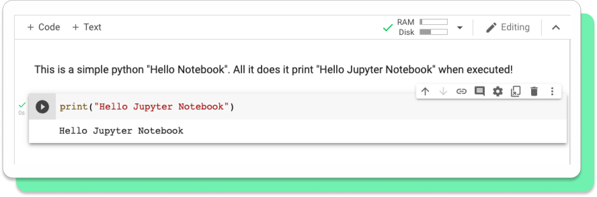

## ****Where is my code being executed?****

As we said previously, a Jupyter notebook allows you to write and annotate Python code interactively in your browser. But many Machine Learning applications are very computationally intensive and can take hours or even days when running on your CPU. Running on a GPU can often speed up to 10 times the execution of your Machine Learning algorithms. But ****you probably don't have access to a GPU on your local machine, are you?**** That's where ****Google Colab comes into play.****It ****allows you to run Jupyter notebooks**** (and thus Python code) ****from your browser on a GPU that Google makes available to you**** on demand. This gives you the same experience as running on your local machine while allowing you to use one or several GPUs on Google.

If you are curious and want to learn more, here is a [**short video**](https://www.youtube.com/watch?v=inN8seMm7UI) that will give you an overview of Google Colab.

Otherwise, you are now ready to get started and in the next lesson, we will guide you through writing and executing your first lines of code inside a Jupyter Notebook.

**Running your first lines of code:**

In this lesson, you will import and run your first ****Jupyter Notebook**** into ****Google Colab**** (or Colaboratory) to get your work environment ready.

To use the Colaboratory, you have to login in with your Gmail email account so the work you make can be saved inside your Google Drive. If you don't have one, you can get a new email address by creating your [Google Account](https://www.google.com/account/about/).

****Run your first lines of code: "Hello World" Jupyter Notebook****

We have created a basic ****"Hello World" notebook**** for you to open and run inside Colab to make sure everything works and you are ready to go.

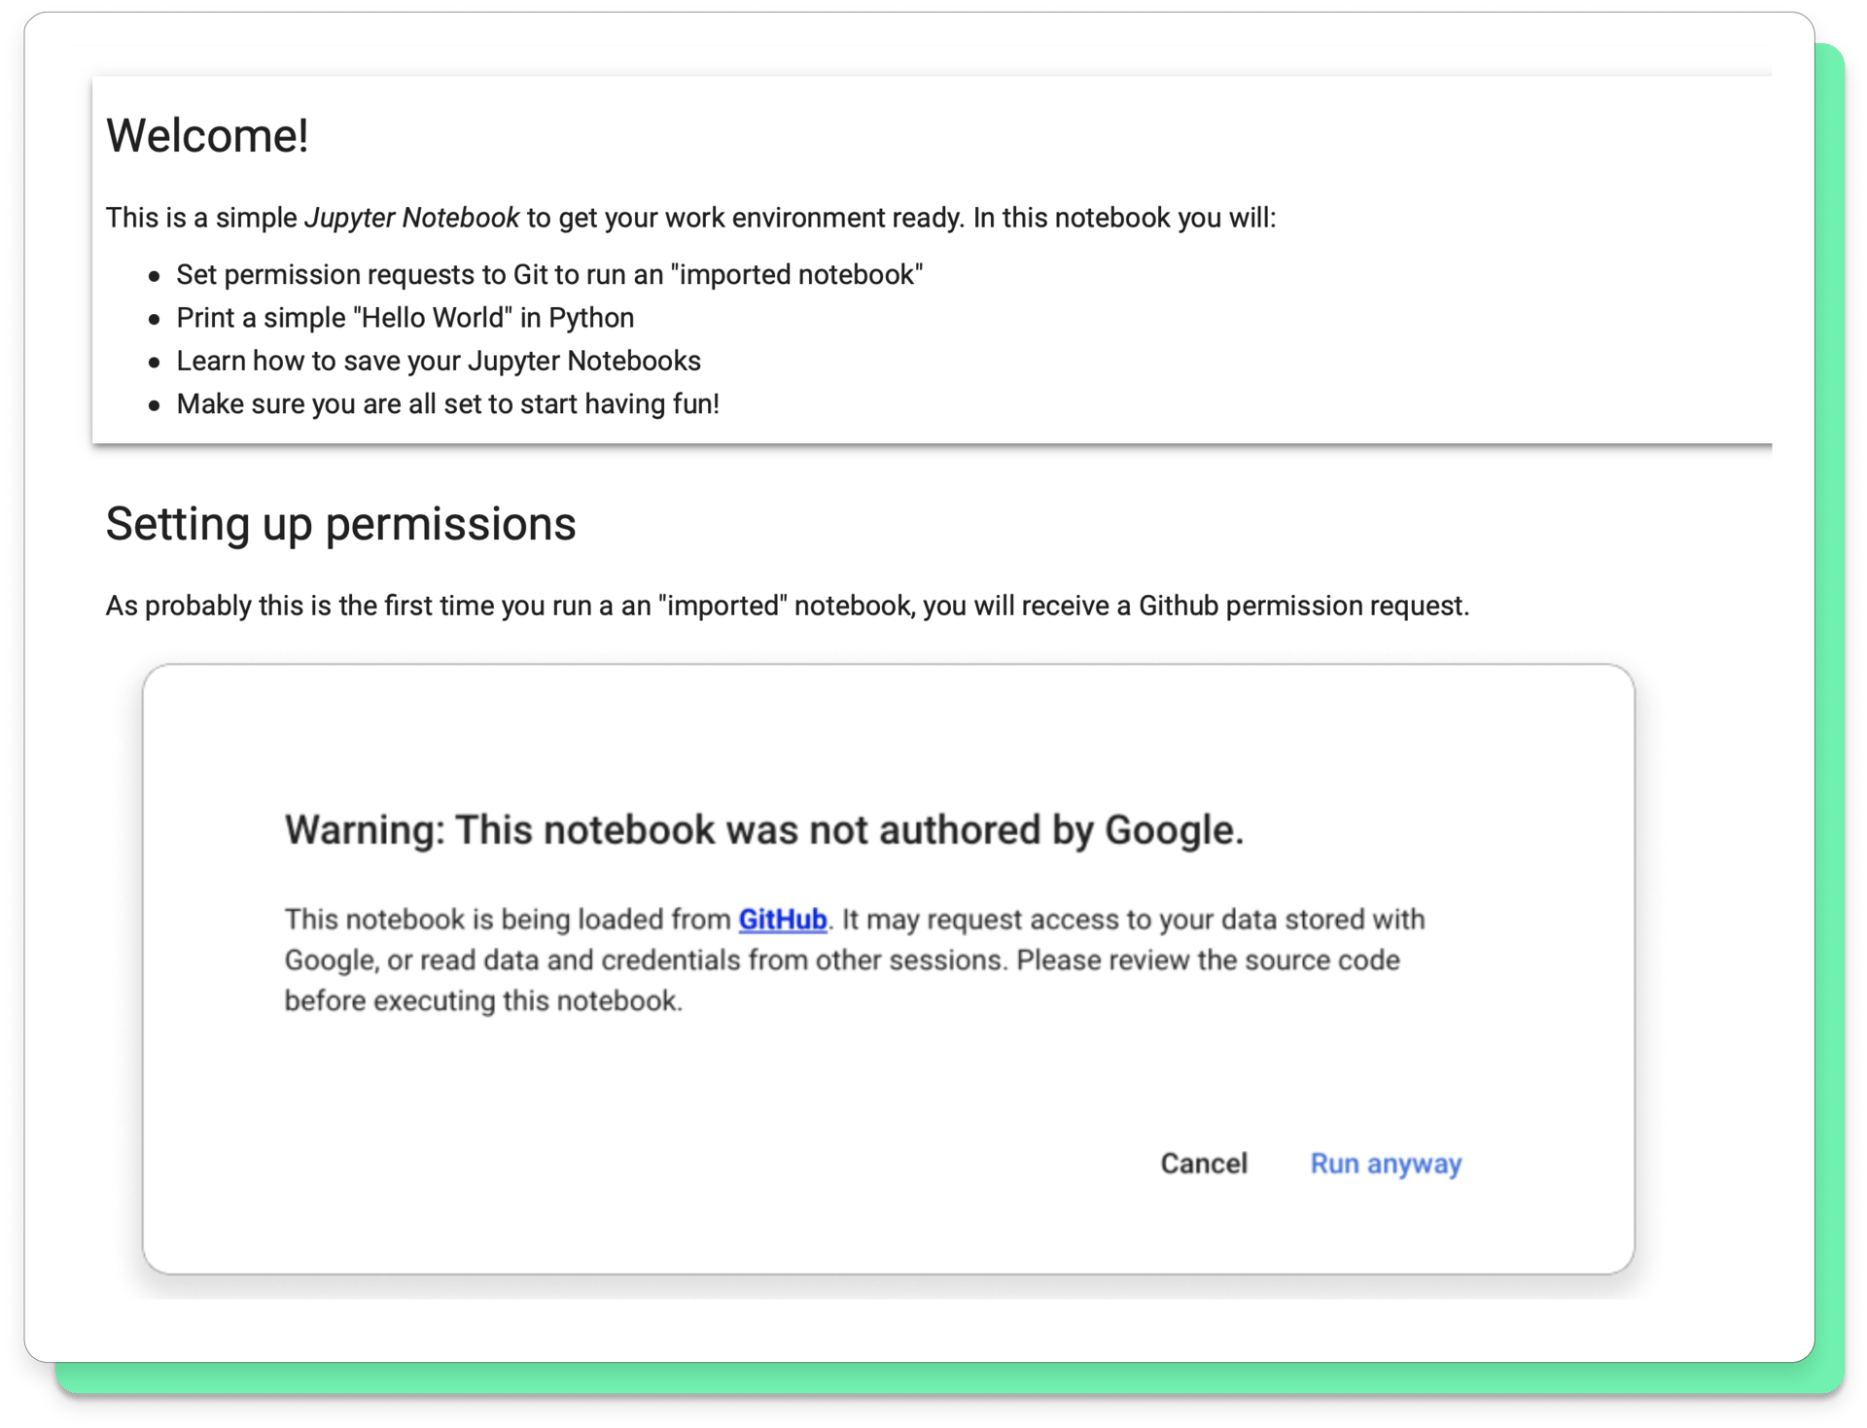

Click on the button ****"Start coding"****and the Hello World notebook will be open in a new tab in your browser. You should see the content like the image below. Follow the exercises in the notebook and come back to the course once you finish.

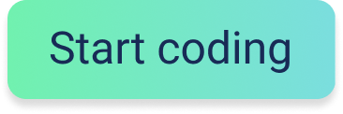

With your work environment up and running, ****you are now ready for the next step, the Course Prep.****